M.Sc (PG) Department of Statistics
Activities in 2019-2020
The department was established in the year 2019.
S No | Programs | Title | Date | Resource person
1 | Guest lecture | Applications of Statistics in various fields & Career Guidance | November 9th 2019 | Mr. Anil Kumar Thota,  Deputy General Manager in CTS.
2 | Guest lecture | Data Science 101 Magic’s of Python with Statistics | January 4th 2020 | Mr. VivekMallampati,  Bachelor of Mathematics & CS @ university of Illinois. USA
3 | Online Quiz | Basic statistics | June 4th 2020

Report on Guest lecture 1:
Department of statistics conducted guest lecture on 9/11/2019 on “Statistics in Various fields& Career Guidance” by Mr. Anil Kumar Thota , Deputy General Manager, cognizant.
The program started by lightning of the lamp with guest & Principal Dr. J NageshwarRao. The guest started his lecture Mr. Anil Kumar discussed about statistics with real life examples he also introduce the participants in many exclusive examples and case studies in Business, Economics, Bio-Statistics & Data Modeling’s. He also shared his personal experiences about his career. The students were able to know about the various skills like R, Python, SAS, SPSS & Advanced Excel, that are required being an informative speaker then he shared the skills required for a leads to excel in the job.
It was very informative & interactive that the students able know about the carrier guidance in statistics. It was wonderful knowledge sharing & gaining lecture.
Feed Back from Students:
- The students were impressed by the lectures.
- It was useful and quite interesting.
- By the lecture we came to know about the opportunities that we are going to have in the future.
Photos:
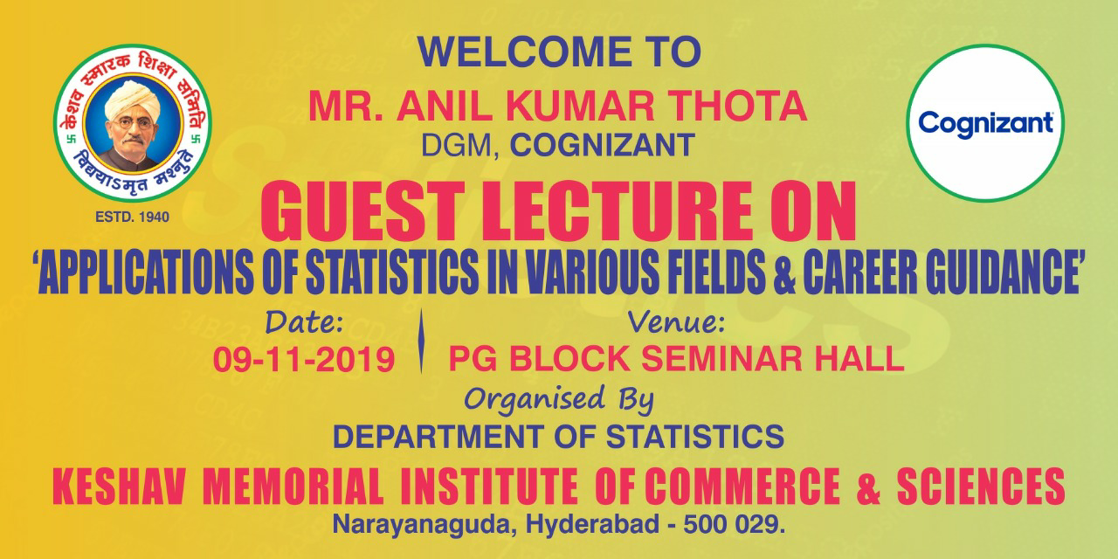
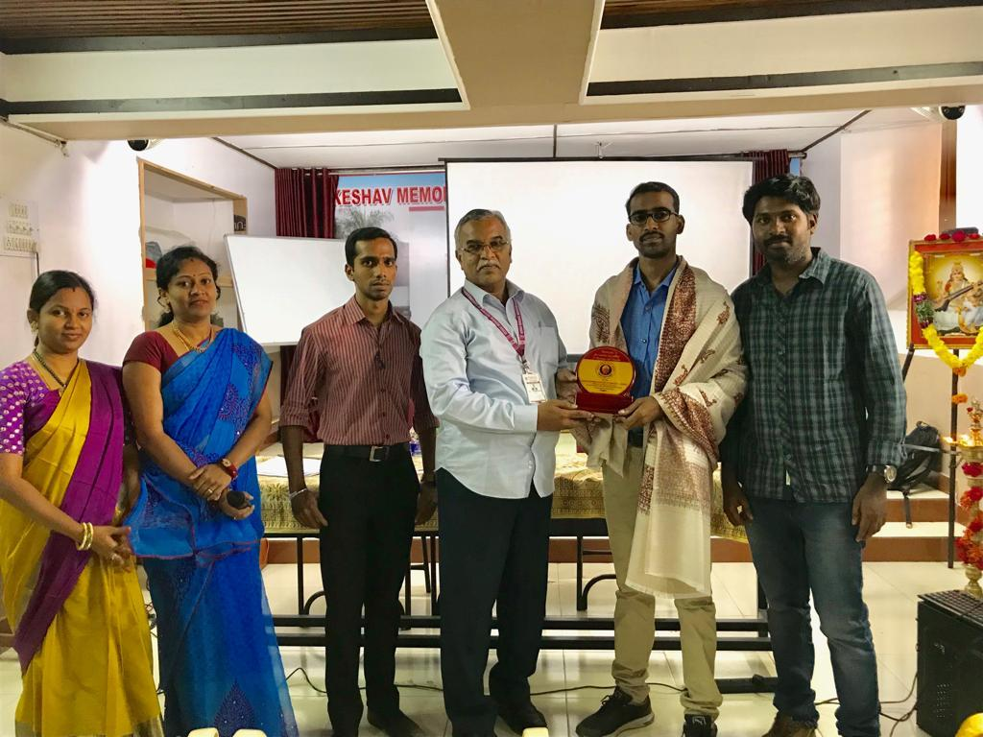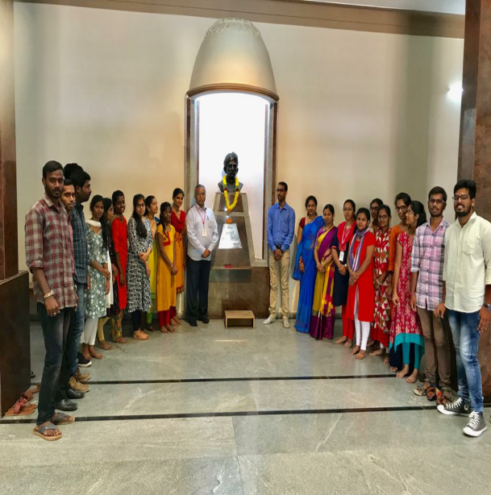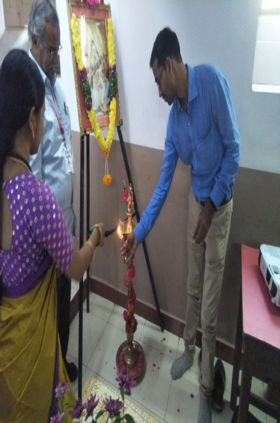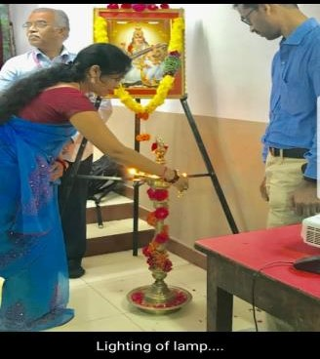
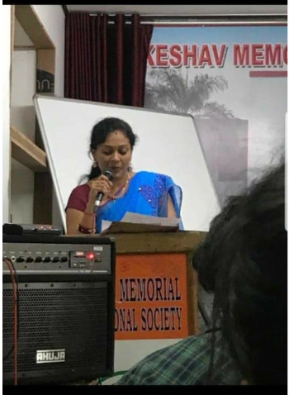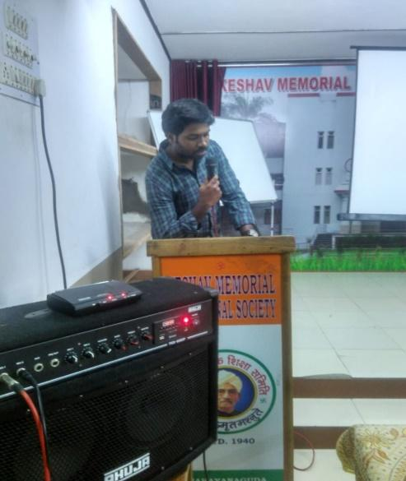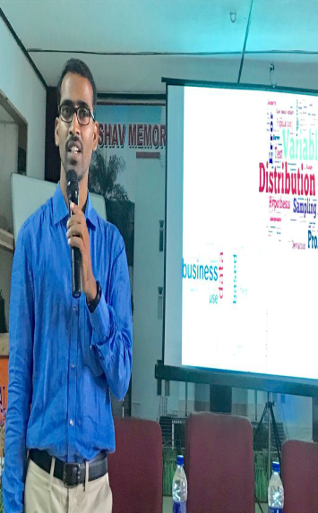

Report on Guest lecture 2:
Department of statistics conducted lecture on 4/1/2020 on “Data Science 101 Magic’s of Python with Statistics” by Mr. VivekMallampati, Bachelor of Mathematics & CS @ university of Illinois. USA.
The program started by Hands - on training for Python activity by using codelabs. He spoke about the Data Science and how it is used in Statistics &computer science. He explained the need of Data Science in Big Data Analysis. He gave about money, scope, opportunities and passion.
Scope of Data Sciene:
He gave examples service based companies like IBM, Uber, MUsigma, etc.
He gave examples product based companies like Amazon, flipkart, paytm etc.
Students Feedback:
- Students were impressed a lot by the activity of Big Data Analysis.
- This lecture created interest in Data Science and Big Data Analysis.
- He gave career guidance to students in Data Science.

Photos:
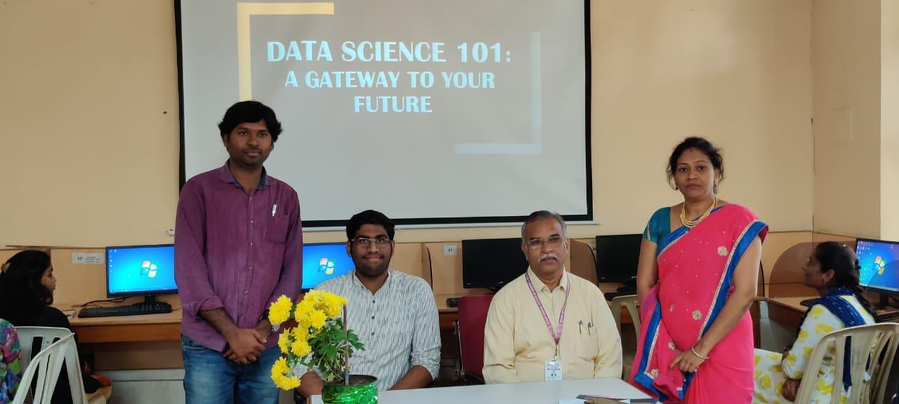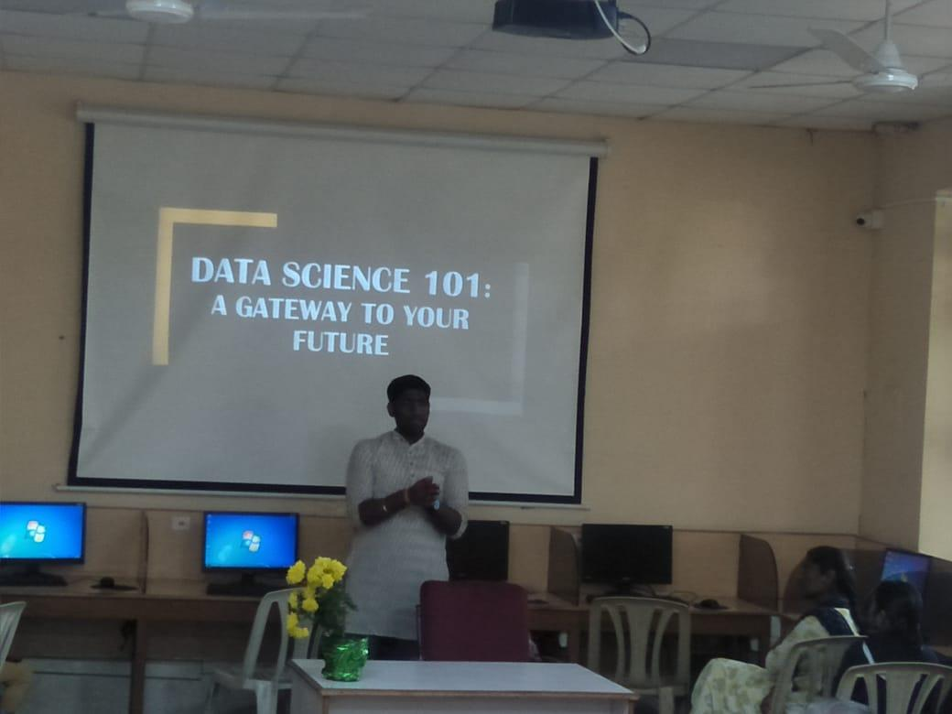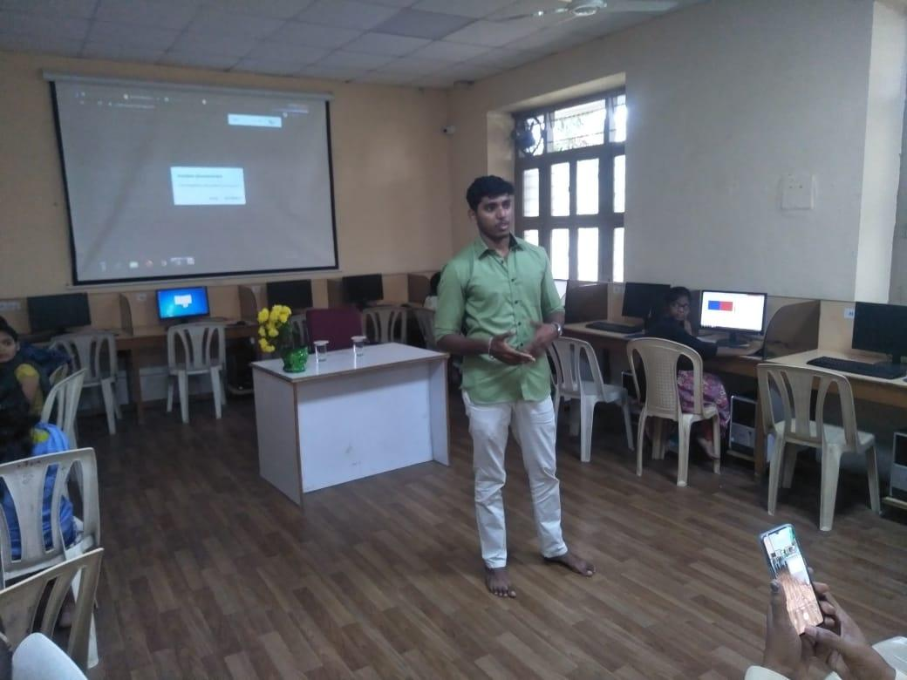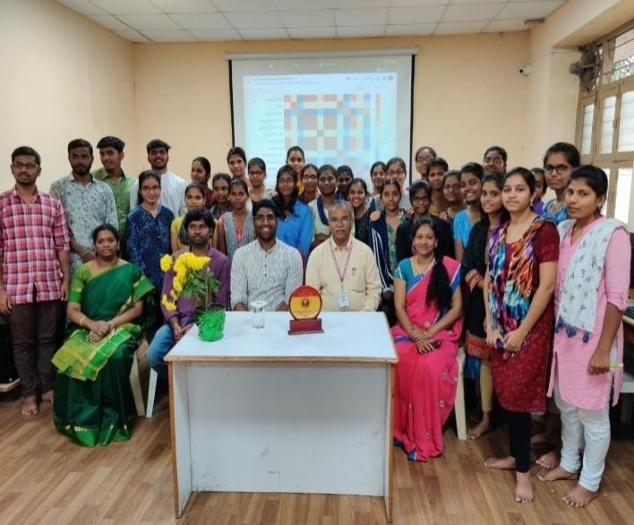

VIRTUAL QUIZ ON 4th June 2020
REPORT ON “STATISTICS QUIZ”
Dept. of statistics conducted one day online Quiz on "Basic Statistics” on 04-06-2020.The Quiz form enabled @ 09:00 a.m. and it disabled @ 09:00 p.m.
And we got 748 responses from participants.
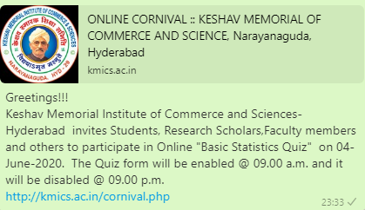
Those who got 60% and above received certificate through virtual.
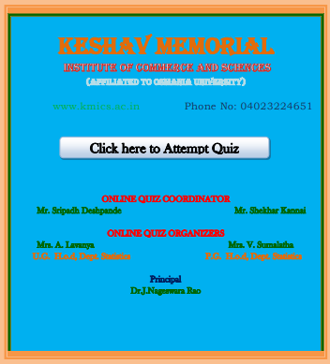

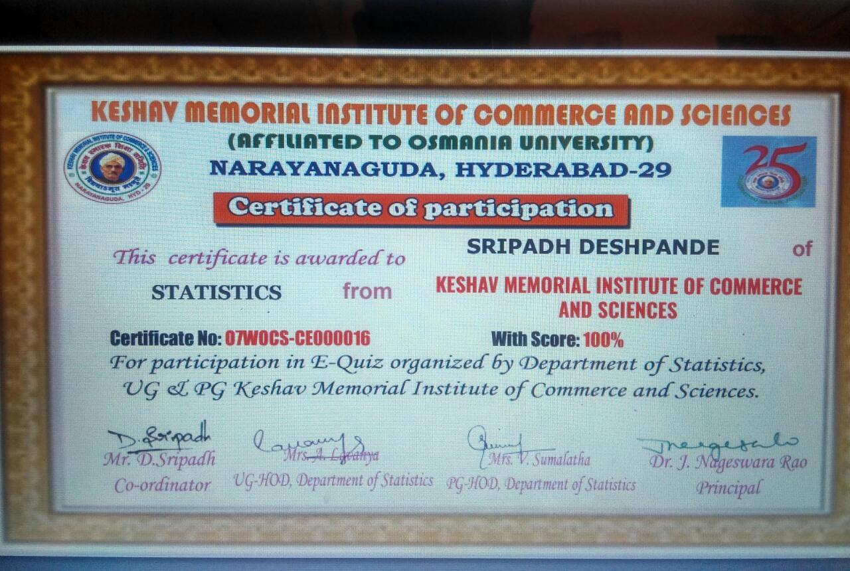

Statistics Departmental Activities in 2020-2021
1 | Classroom activities | Statistics Tambola, Group discuss, PPT’s | November 14th 2020
2 | Skill Hunt | A virtual platform to prove your talent | August 2nd 2020
3 | Classroom activities | Celebration of 131st Birth Anniversary of R.A.Fisher | February 17th 2021
4 | Guest lecture | Emerging Roles and career growth in the current industry | February 26th 2021 | Mr. K.Raju –Manager, Data science IBM.

Class Room Activities:
- Statistical Tambola: it was an inter class competition initiated by the students Marina Judy, B. Swathi, K. Bhavani. B. Maheshwari, S. Pranaya.
They created interest statistics through tambola.
S.No |  | Winner & Runner | Date
1 | House Full | D. Bhavyasai (Stats)  &Akhila (Maths) | 15/11/2019
 | 1 st RowWinner | S J Shiva (Stats)
 | Jaldi Five | H. Akhila(Stats)
Photos: 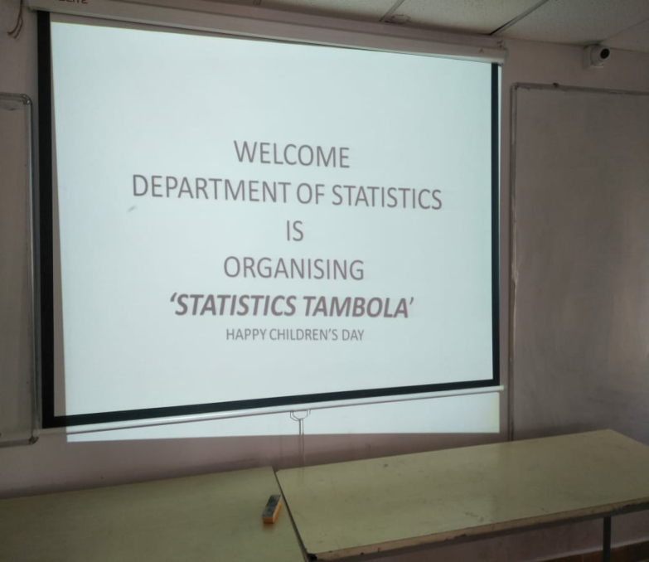
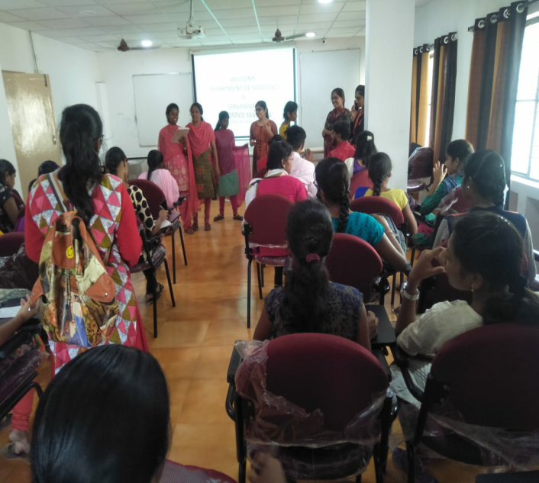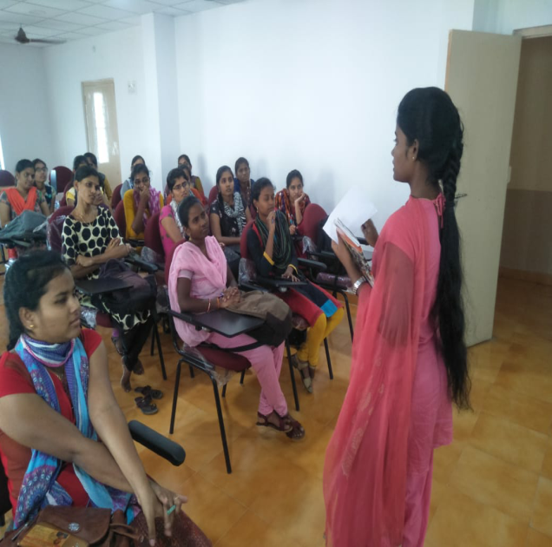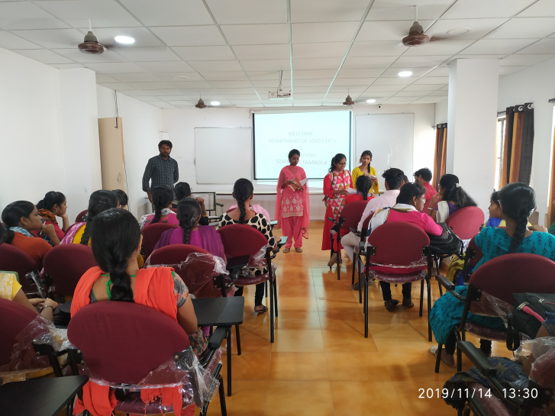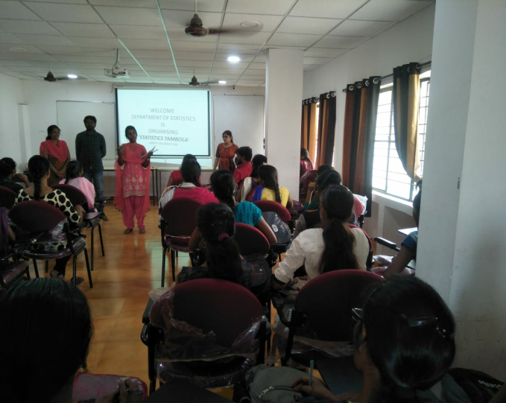

- Group Discussion: it was an inter class competition on Social issues and Data scienceis the new oil. On 16/11/2019
Winner | Runner
G. Harika (Stats)  G. Prathyusha (Stats) | N. ManasaRao (Stats)  DayaSagar (Maths)

Group Discussion photos:
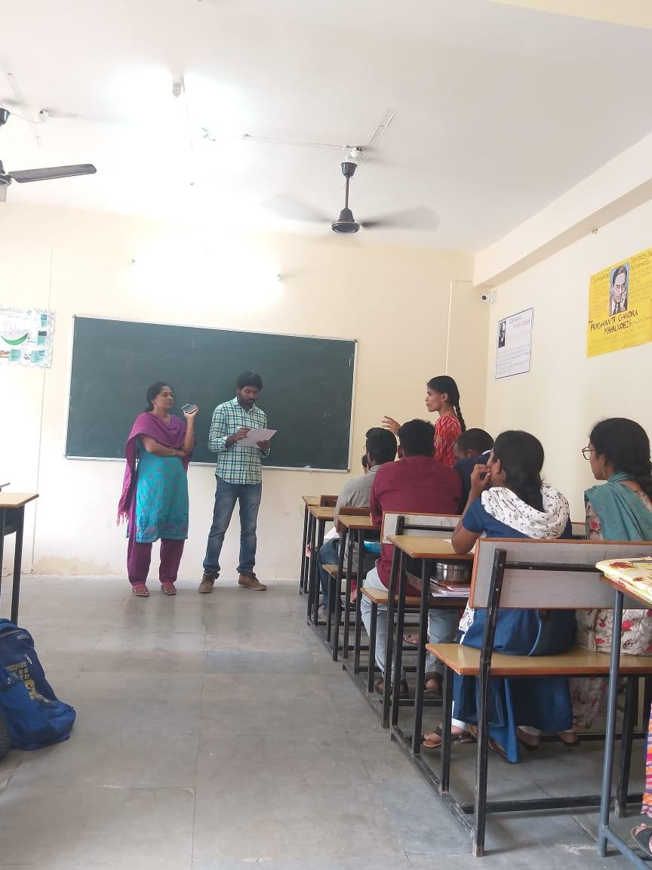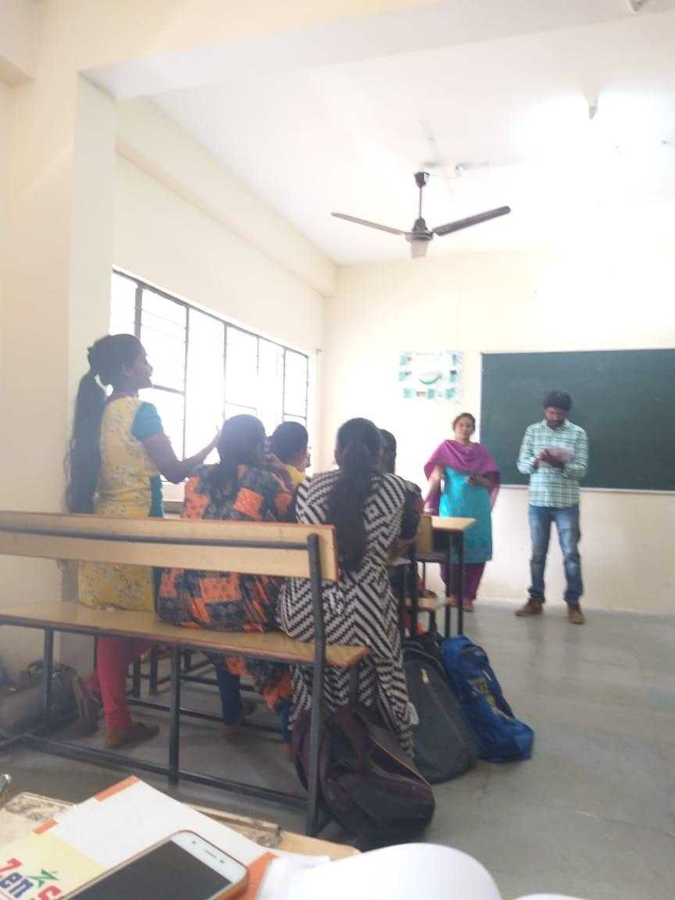
- PPT:
PPT was presented by Marina Judy on Statistical models, uses and examples for the Data Modeling. Forecasting the data.

- Inter Department Activities: Our students were actively participated in inter department activities
SNo | Program Name | Date | Winner | Runner
1 | PG Science club competitions | 7 th& 8 th Nov 19
a | Best out of waste |  | B. Bhavana
b | Food competition |  | SJ Shiva | Consolation prize : G. Prashanth
c | Poster Presentation |  |  | B. Bhavana
2 | Quiz competition | 2 nd Nov 19 | Marina Judy & Group
3 | JAM | 8 th Nov 19 | Y. Yashawani

Quiz competition photos:
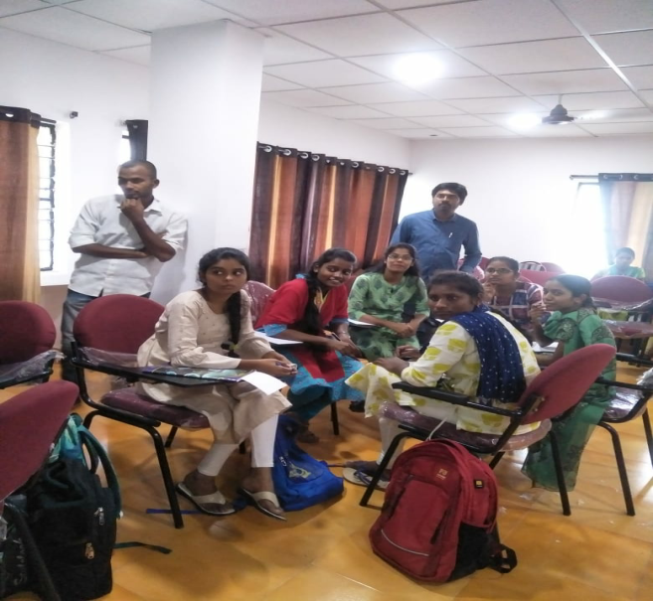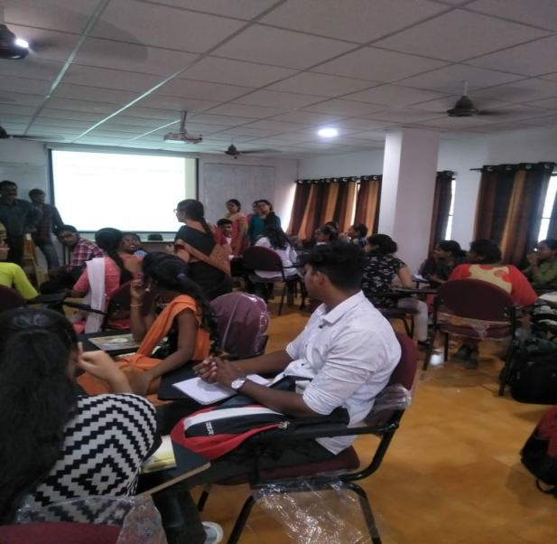
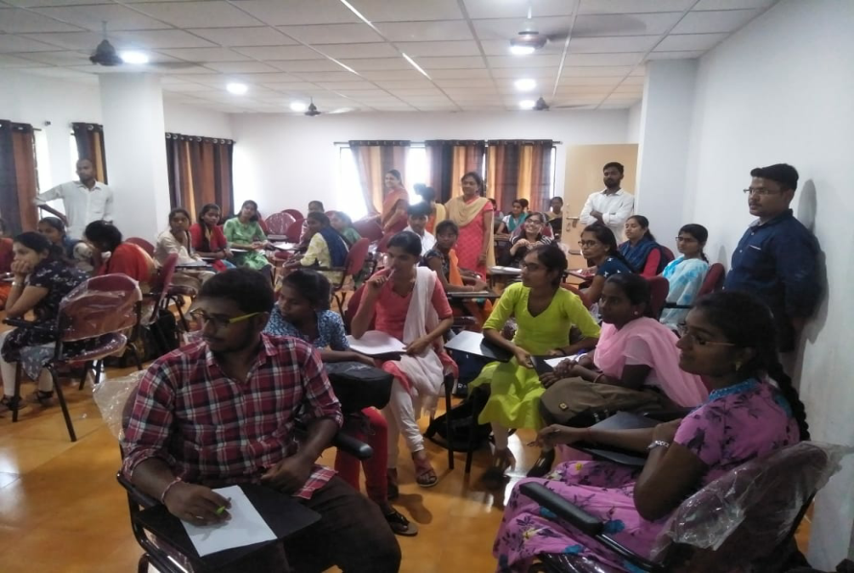
Jam Photos

Induction Day:
Induction day was conducted on 18/11/2019 in SP hall. Our students actively participated in cultural activities.
Future Plans:
- We will plan for field trip.
- Workshops and seminars.

VIRTUAL SKILL HUNT ON 2nd August 2020
REPORT ON “SKILL HUNT”
A Virtual program “SKILL HUNT” was conducted by the department of statistics during to lockdown in the month of august. The main aim behind it was to provide “A Virtual platform to prove their talents”
In the competition the students were asked to send their skills like Singing, Dancing, Painting, Cooking, and many more in the form of photos and short videos by 30th July 2020and the prizes were distributed on 2nd August 2020.
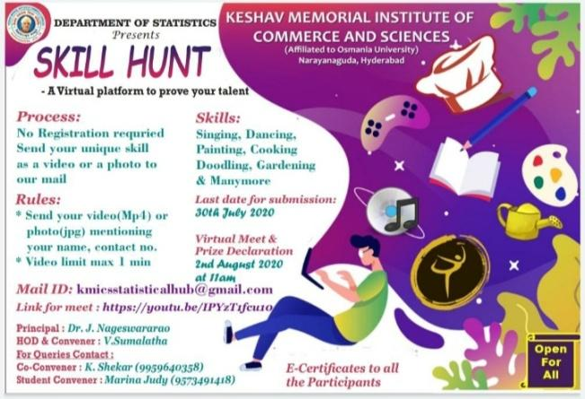
The Virtual program started by enlightening the participants about the achievements of the College and the Department of Statistics by HOD V.Sumalatha followed by a Welcome dance by Shriyashree of Bsc.MSCS .After which the participants were addressed by our principal DR.J.Nageswarao . Our guest “AsfiyaKhannam- A Blogger and content“ spoke about her experiences and how she achieved the goals in a short span of time.

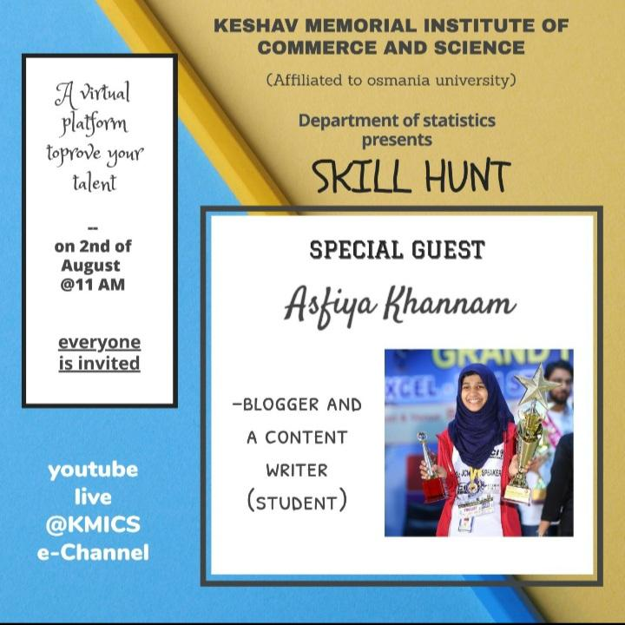
Then video giving glimpses of all the entries received were displayed. After which the winners were announced by our Principal in 14 categories displaying their virtual certificates, then the winners spoke about their experience and what inspired them. And the program ended with the vote of thanks by Sripadhdeshpandey– lecturer in Statistics.
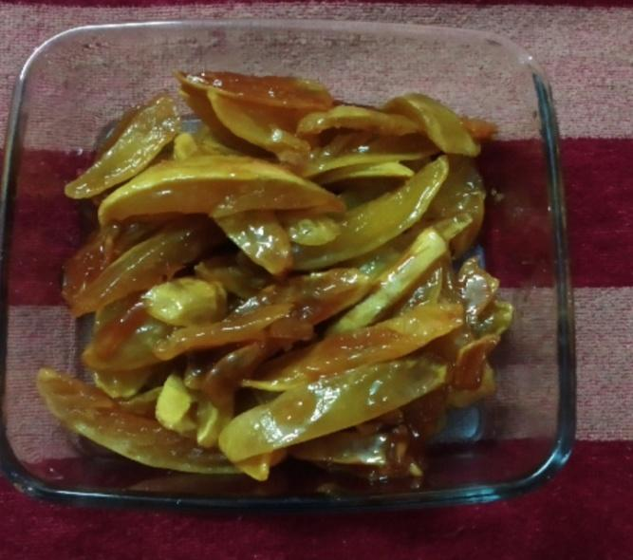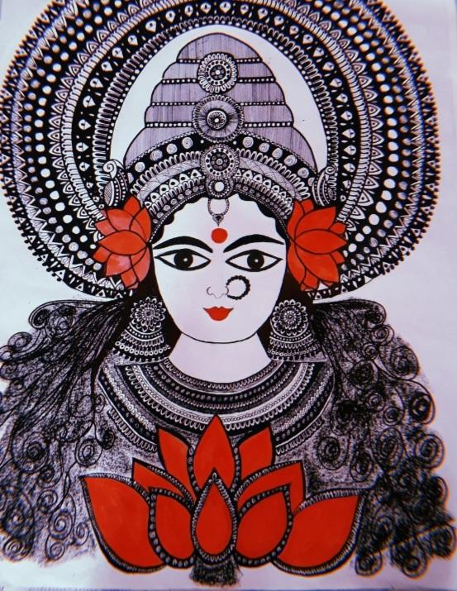
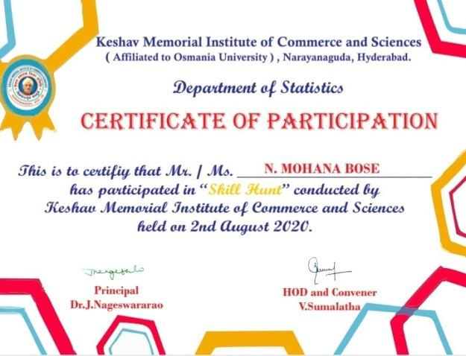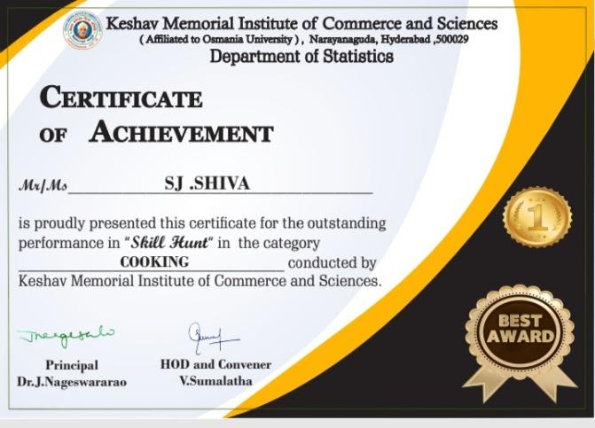

The program was attented by more than 1500 viewers and more than 100 participants which included participants from all over telangana and also from other states like TamilNadu, Assam, Bihar, Madhya Pradesh, and Andhra Pradesh
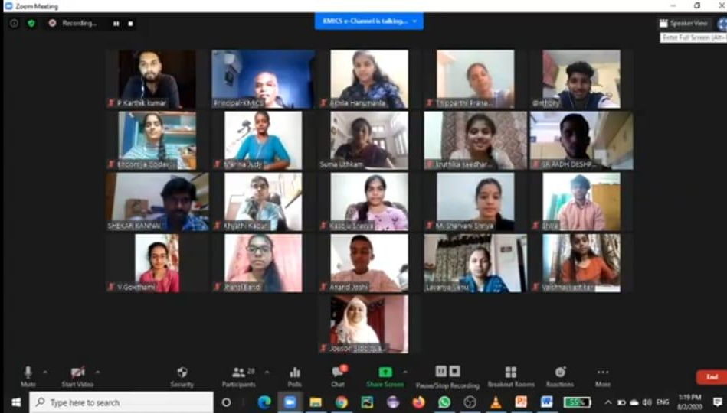
Feedback from Students:
- The students were delighted by opportunity given to them to showcase the skills
- The students requested that more such programs should be conducted.
Report on the Celebration of 131st Birth Anniversary of R.A.Fisher
The Celebration started by enlightening the students about the achievements of R.A.Fisher
By HOD of Statistics V. Sumalatha followed by a quiz competition conducted for the students of MSc. Statistics by kankareddy lecturer in statistics . Quiz was conducted on the topics Time Series, Descriptive Statistics, Parametric Inference, Sampling techniques.
SNo | Program | Winner/Runner | Date
1 | Quiz | - Marina Judy  - B. Swathi | 17/02/2020
2 | Quiz | 1. S. Pranaya  2. k.Bhavani | 17/02/2020

Followed by Prize distribution by our Principal Prof.k. Someswarao
And a floral tribute to R.A.Fisher was given by the principal, lecturers of the department of statistics and students .
After which the students H.Akhila and Marina Judy shared their knowledge about R.A Fisher with all the participants. The program ended with the vote of thanks by HOD V.Sumalatha

Photos:
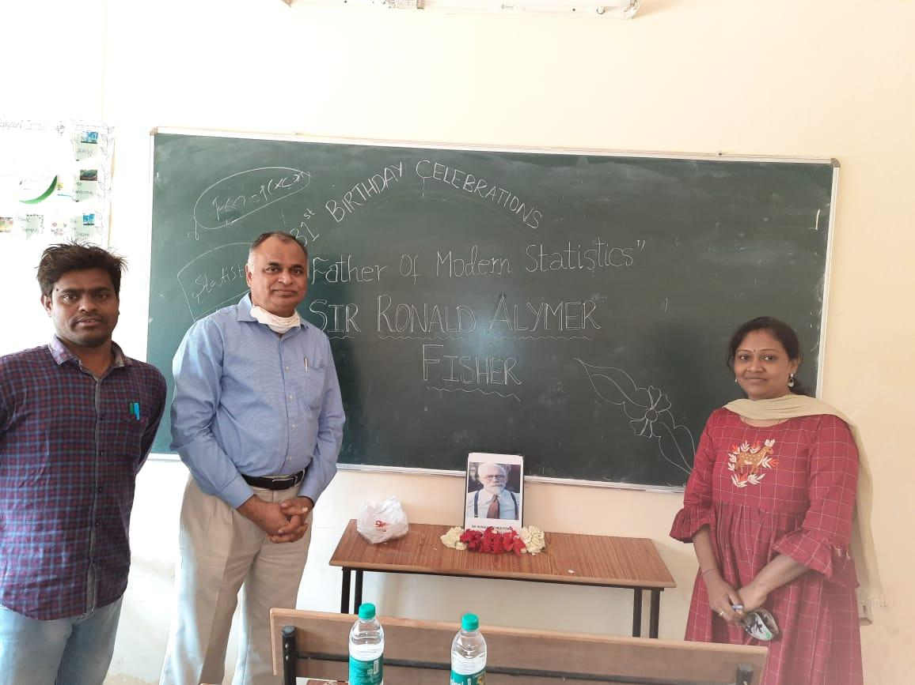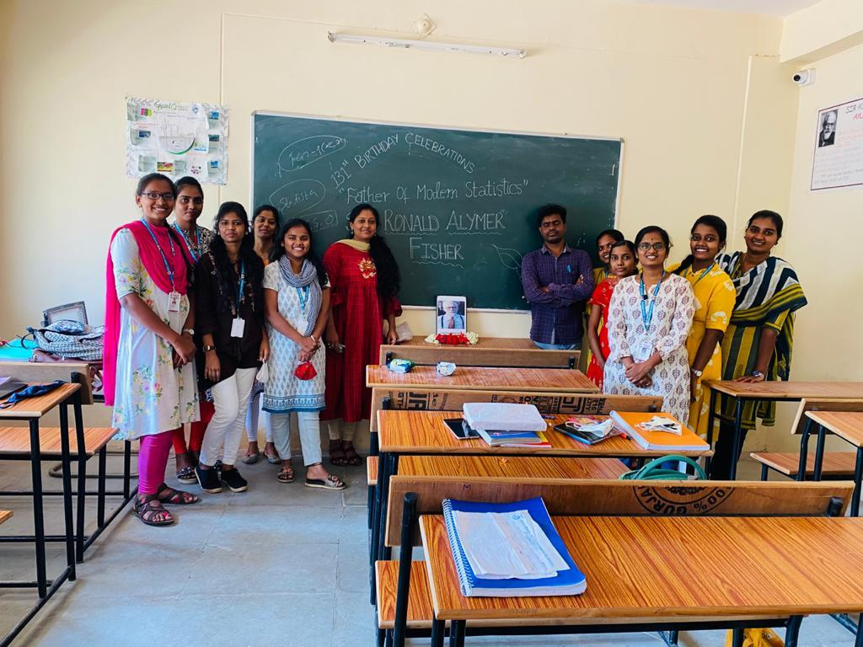
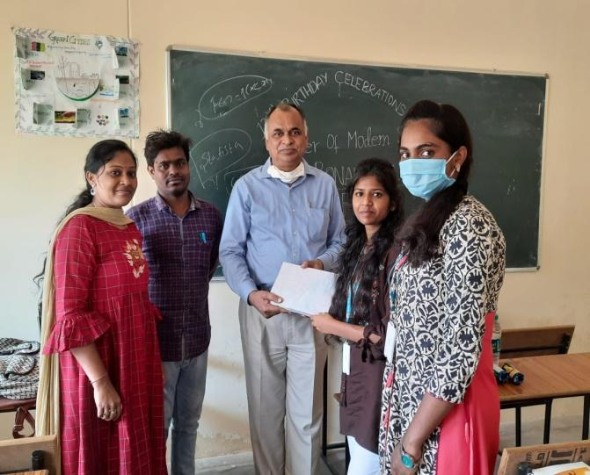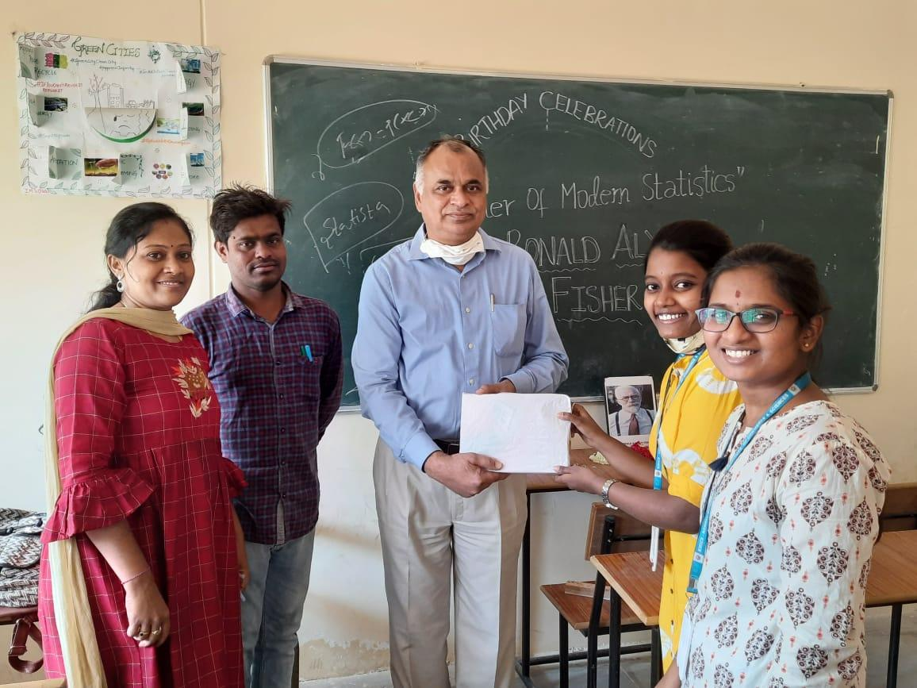

Report on Guest Lecture about Career Guidance
A guest lecture was conducted on “EMERING ROLES AND CAREER GROWTH IN THE CURRENT INDUSTRY” on 26th February 2021 by K. Raju –Manager, Data science IBM.
The program started by the introduction about the guest by A. Lavanya , followed by addressing of the audience by our Principal.
The guest spoke about the Career Growth in the current industry and explained in detail the roles for the students of statistics. He portrayed with live examples the uses of statistics.
After which the guest was felicitated by the management and Department of Statistics
And the program ended with the vote of thanks by Marina Judy student of MSc. Statistics .
Photos:

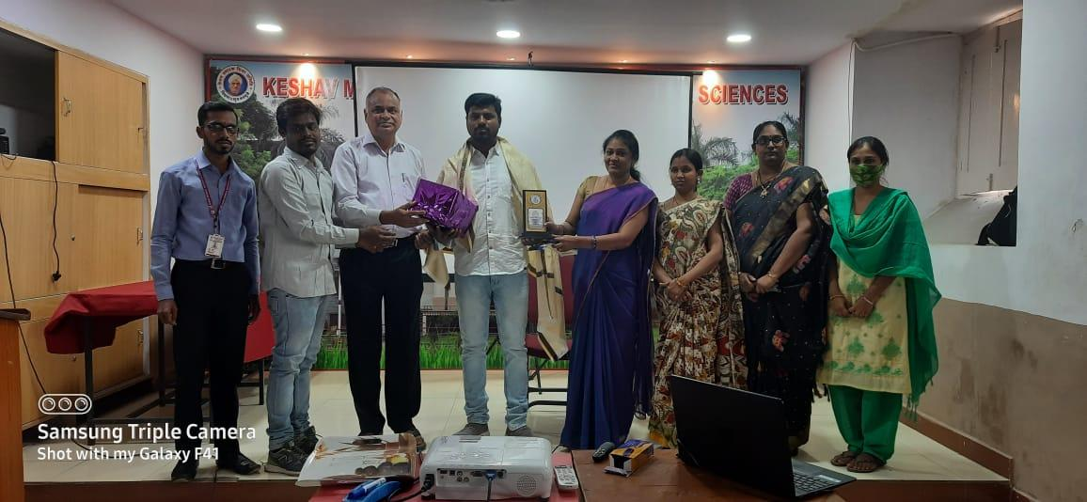
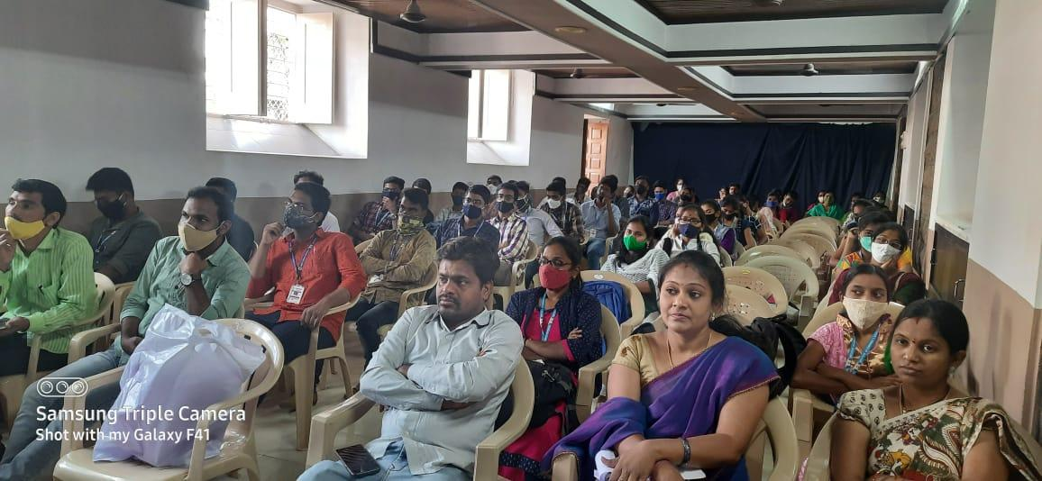
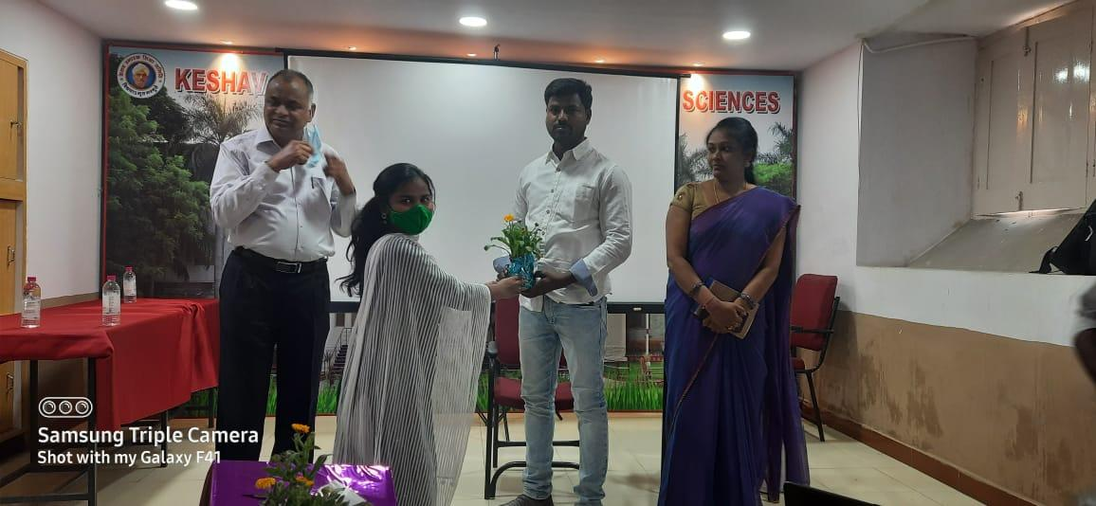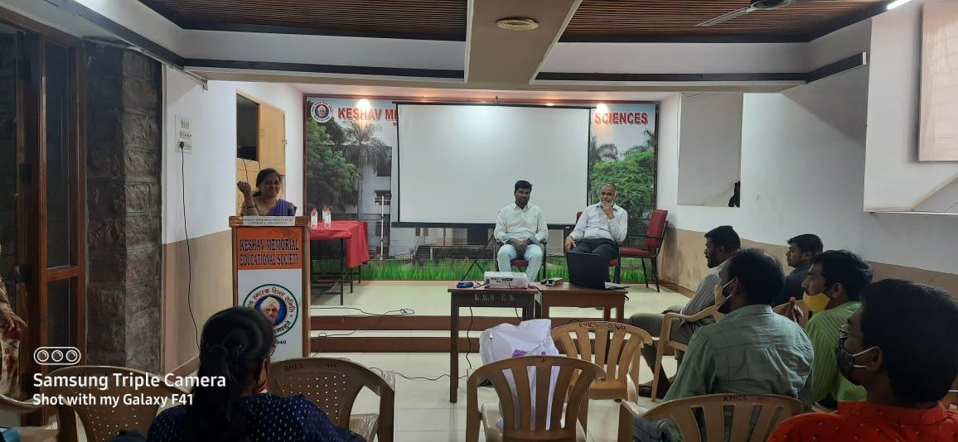

Students feedback :
- Students came to know about their career opportunities .
- They came to know about the real time use of Statistics

